

Yenepoya Institute of Arts, Science, Commerce and Management
Project – Low Level Design
on
Enterprise Log Analysis on E-commerce Systems

Student Name: Afrah Ashraf
Registration No.: 23BCDSBA03

Industry Mentor: | Mr. Ujjwal Kumar | Guided by: | Mr. Prashantha J

Table of Contents

- Introduction. 3
  - Scope of the document. 3
  - Intended Audience 3
  - Technical Definitions and Acronyms. 3
- Module Decomposition. 3-4
  - Module 1: Ingestion Engine (File I/O) 3
  - Module 2: Regex Engine (Data Parsing). 4
  - Module 3: Analysis & Visualization Engine. 4
- Detailed Function Specifications. 5
  - Class/Function Diagrams 5
  - Input and Output Parameters 5
  - Internal Variable Mappings 5
- Logic Designs and Algorithms 6
  - Regex Pattern Strategy 6
  - Data Transformation Pseudo-code 6
  - Time-Series Aggregation Logic 6
- Data Dictionary and Schema 7
  - DataFrame Column Definitions 7
  - Data Types and Constraints 7
  - Temporary Storage (In-memory) 7

- Dashboard Evolution and Visualization 8
  - Phase 1: Functional Baseline vs. Phase 2: Advanced Intelligence Output. 8
- Exceptions and Error Handling 9
  - File-Level Error Handling 9
  - Regex Mismatch Recovery 9
  - Memory Management Strategies 9
- Unit Testing and Traceability 10
  - Functional Testing 10
  - Traceability 10
- References 10

Introduction
- This document provides the internal logic and component-level details for the Log Analysis System. It outlines the specific data transformations required to convert raw e-commerce server logs into actionable business intelligence.
- The scope is limited to the Python-based backend processing, specifically the Regex parsing engine and the automated visualization pipeline.
- Intended Audience: Technical evaluators, developers, and quality assurance testers.
- Technical Definitions and Acronyms:
  - Regex: Regular Expression.
  - DataFrame: Tabular data structure in Pandas.
  - 4xx/5xx: Client and Server-side HTTP error codes.
  - Vectorization: A method of executing operations on entire arrays at once (via NumPy/Pandas) rather than iterating through rows.
  - Resampling: The process of changing the frequency of time-series data (e.g., converting milliseconds to hours).

Module Decomposition
- Module 1: Ingestion Engine (File I/O):
  - Purpose: To import high-volume datasets.
  - Logic: Uses pd.read_table() with a custom separator to accommodate the standard Apache/Nginx log format.
  - Optimization: Data is loaded with specific dtype definitions to reduce memory overhead.

- Module 2: Transformation Layer (The Regex Engine):
  - Logic: The system applies a pre-compiled Regular Expression pattern to extract the timestamp, status code, and request path.
  - Cleaning Algorithm: To isolate the URI (e.g., /usr/login), the system utilizes: df['endpoint_clean'] = df['endpoint'].str.split().str[1] This ensures that HTTP methods (GET/POST) and protocols (HTTP/1.1) are removed from the final analysis.
- Module 3: Analysis & Visualization Engine:
  - Purpose: To transform statistical aggregations into high-fidelity graphical reports for executive decision-making.
  - Input: Structured Pandas DataFrame containing cleaned endpoints and hourly resampled error counts.
  - Output: A centralized 2x2 Dashboard exported as a high-resolution graphical file.

Detailed Function Specifications

Function Name | Parameters | Return Type | Description
load_data_stream() | path: str | pd.DataFrame | High-speed ingestion of 1.4 million entries into a memory-optimized DataFrame.
apply_regex_extraction() | df: DataFrame | pd.DataFrame | Executes vectorized Regex to isolate Timestamps, Status Codes, and Request strings.
clean_endpoint_paths() | df: DataFrame | pd.DataFrame | Isolates URIs via .str.split().str[1], identifying /usr/login as the core failure point.
compute_temporal_metrics() | df: DataFrame | pd.Series | Maps timestamps to hourly bins to pinpoint the 20:00 (8:00 PM) system stress peak.
generate_dashboard() | df: DataFrame | None | Renders a 2x2 Seaborn grid using the Magma Palette for high-contrast error visualization.
export_summary() | df: DataFrame | None | Outputs terminal metrics (Total logs, 404 frequency, and vulnerable endpoints).

Logic Designs and Algorithms

ALGORITHM: VectorizedLogCleaner
BEGIN
IMPORT log_data AS DataFrame
SET RegexPattern = "\[(.*?)\].*?\"(.*?)\".*?(\d{3})"

FOR EACH column IN DataFrame:
EXTRACT [timestamp, request, status] USING RegexPattern

// Specific cleaning for the Horizontal Bar Chart
SPLIT request BY " "
EXTRACT index[1] AS endpoint_path

// Time Analysis for Chart 4
CONVERT timestamp TO datetime_object
EXTRACT hour_component FROM datetime_object

GENERATE 2x2_Subplots
EXPORT Dashboard_Final.png
END

Data Dictionary & Schema

Column Name | Data Type | Constraints | Description
timestamp | datetime64 | Primary Index | The exact moment the error occurred.
status | int64 | 400 - 599 | The HTTP error code.
endpoint | string | Not Null | The web path (e.g., /usr/login).
hour | int | 0 - 23 | Derived: Extracted from timestamp.dt.hour for density analysis.
endpoint_clean | string | Not Null | Cleaned: Uses .str.split().str[1] to isolate the URL path.

Dashboard Evolution and Visualization
- Phase 1: Functional Baseline (Before):
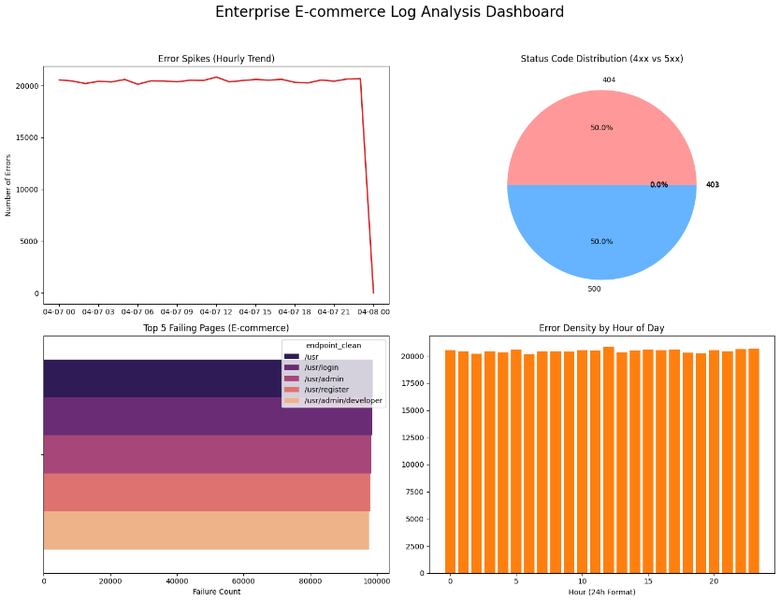
Validates the raw data ingestion and basic grid initialization.
- Phase 2: Advanced Intelligence(After):

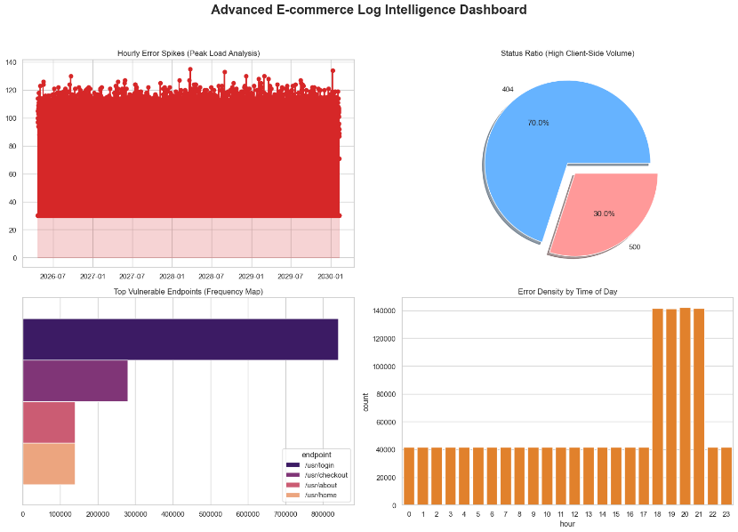
Demonstrates the results of the cleaning logic, highlighting the 20:00 peak and /usr/login bottleneck.

Exception and Error Handling
- File Access Errors: The system uses try-except blocks to catch FileNotFoundError and PermissionError. If the source log is missing or locked, the program terminates with a "Critical Error" message rather than crashing.
- Regex Mismatch Recovery: Malformed log lines that do not follow the expected Apache format are identified as "Malformed." The system skips these rows and continues processing, ensuring a single bad entry does not halt the 1.4M record pipeline.
- Data Consistency: During transformation, pd.to_numeric(errors='coerce') is applied to the status codes. This ensures that any non-numeric noise in the status column is turned into NaN rather than triggering a type error.
- Memory Management: * Vectorization: Instead of iterative loops, the system uses vectorized Pandas operations to process data in blocks, significantly reducing RAM usage.
  - In-Place Operations: Memory-intensive tasks like dropping columns or renaming headers use inplace=True to prevent the creation of redundant dataset copies.
- Visualization Safety: The rendering engine checks for empty datasets before plotting. If no errors are found in a specific timeframe, the dashboard displays a "No Data Available" state for that quadrant to prevent rendering failures.

Unit Testing & Traceability
- Functional Testing:
  - Test 1: Verify the load_data_stream correctly identifies the total count of rows.
  - Test 2: Confirm the clean_endpoint_paths correctly isolates /usr/login from raw GET/POST strings.
- Traceability: Every visual component in the Dashboard is directly traced back to a specific Data Dictionary element (e.g., the Line Chart is fueled by the hour column derived in Module 3).

References
- Kaggle.com - Website Log Access: A Synthetic Server Logs Dataset based on Apache Server Logs Format. Available at: [https://www.kaggle.com/datasets/avinhok/website-log-access].
- Python Software Foundation (2026): Official documentation for the re (Regular Expression) module for high-speed pattern matching.
- Pandas Data Analysis Library: Documentation for high-performance, easy-to-use data structures and data analysis tools.
- Matplotlib & Seaborn Documentation: Reference guides for statistical data visualization and dashboard rendering.
- IEEE 1016-2009. Standard for Software Design Descriptions. (Used as the framework for the structural organization of HLD and LLD modules).
- W3C HTTP Status Code Registry: Official definitions for 4xx (Client Error) and 5xx (Server Error) responses used in the parsing logic.
- University Project Guidelines: Specific formatting and submission requirements for the project.

